WEEK 7
TASK 1:
class ParkingSystem {
private int[] slots;

public ParkingSystem(int big, int medium, int small) {
slots = new int[4]; // index 1,2,3 used
slots[1] = big;
slots[2] = medium;
slots[3] = small;
}

public boolean addCar(int carType) {
if (slots[carType] > 0) {
slots[carType]--;
return true;
}
return false;
}
}
OUTPUT :
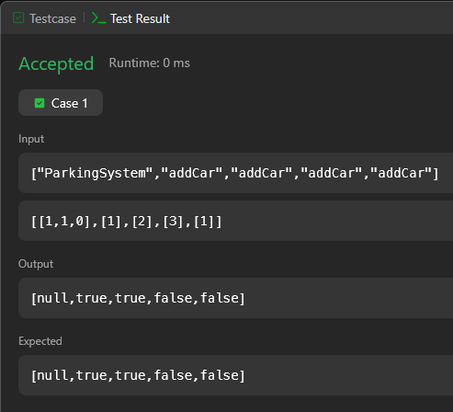
TASK 2:
import java.util.*;

class Student {}
class Rockstar {}
class Hacker {}

public class Solution {

static void count(ArrayList mylist) {
int student = 0;
int rockstar = 0;
int hacker = 0;

for (Object obj : mylist) {
if (obj instanceof Student) student++;
else if (obj instanceof Rockstar) rockstar++;
else if (obj instanceof Hacker) hacker++;
}

System.out.println(student + " " + rockstar + " " + hacker);
}

public static void main(String[] args) {
Scanner sc = new Scanner(System.in);
int t = sc.nextInt();

ArrayList mylist = new ArrayList();

while (t-- > 0) {
String s = sc.next();
if (s.equals("Student")) mylist.add(new Student());
else if (s.equals("Rockstar")) mylist.add(new Rockstar());
else if (s.equals("Hacker")) mylist.add(new Hacker());
}

count(mylist);
}
}
OUTPUT :
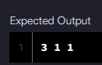
TASK 3:
import java.util.*;

class UndergroundSystem {

Map<Integer, Pair> checkInMap;
Map<String, int[]> travelMap;

class Pair {
String station;
int time;

Pair(String s, int t) {
station = s;
time = t;
}
}

public UndergroundSystem() {
checkInMap = new HashMap<>();
travelMap = new HashMap<>();
}

public void checkIn(int id, String stationName, int t) {
checkInMap.put(id, new Pair(stationName, t));
}

public void checkOut(int id, String stationName, int t) {
Pair p = checkInMap.get(id);
checkInMap.remove(id);

String key = p.station + "-" + stationName;
int time = t - p.time;

travelMap.putIfAbsent(key, new int[2]);
travelMap.get(key)[0] += time; // total time
travelMap.get(key)[1] += 1; // count
}

public double getAverageTime(String startStation, String endStation) {
String key = startStation + "-" + endStation;
int[] data = travelMap.get(key);
return (double) data[0] / data[1];
}
}

OUTPUT :
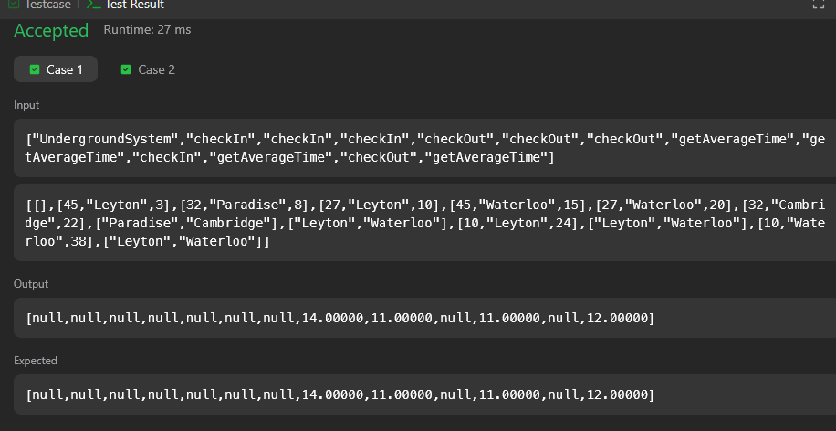
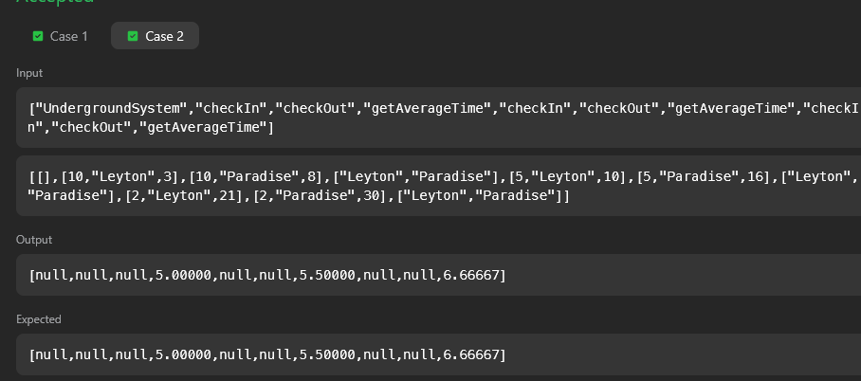
TASK 4:
import java.util.*;

class BrowserHistory {

List<String> list;
int current;

public BrowserHistory(String homepage) {
list = new ArrayList<>();
list.add(homepage);
current = 0;
}

public void visit(String url) {
// remove forward history
while (list.size() > current + 1) {
list.remove(list.size() - 1);
}
list.add(url);
current++;
}

public String back(int steps) {
current = Math.max(0, current - steps);
return list.get(current);
}

public String forward(int steps) {
current = Math.min(list.size() - 1, current + steps);
return list.get(current);
}
}
OUTPUT :
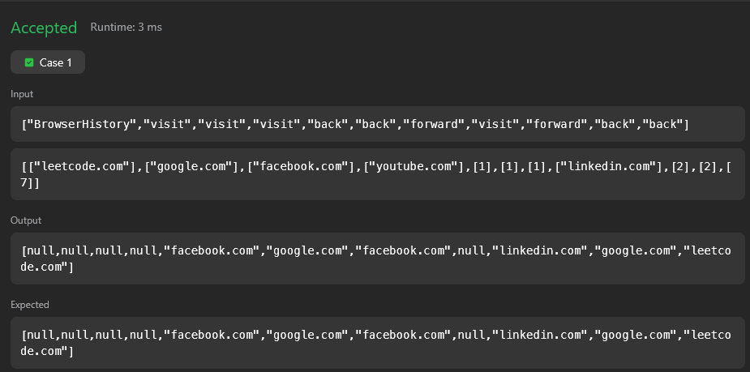
TASK 5:
class MyHashSet {

private boolean[] set;

public MyHashSet() {
set = new boolean[1000001]; // max key = 10^6
}

public void add(int key) {
set[key] = true;
}

public void remove(int key) {
set[key] = false;
}

public boolean contains(int key) {
return set[key];
}
}
OUTPUT :
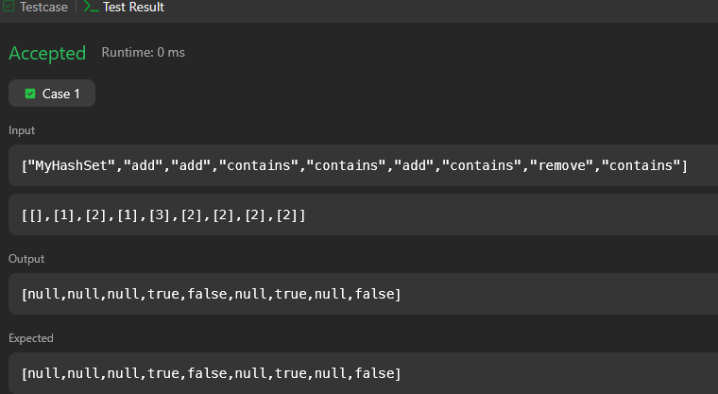
TASK 6:
import java.util.*;

public class Solution {

public static List<Integer> gradingStudents(List<Integer> grades) {
List<Integer> result = new ArrayList<>();

for (int g : grades) {
if (g < 38) {
result.add(g);
} else {
int nextMultiple = ((g / 5) + 1) * 5;

if (nextMultiple - g < 3) {
result.add(nextMultiple);
} else {
result.add(g);
}
}
}

return result;
}

public static void main(String[] args) {
Scanner sc = new Scanner(System.in);

int n = sc.nextInt();
List<Integer> grades = new ArrayList<>();

for (int i = 0; i < n; i++) {
grades.add(sc.nextInt());
}

List<Integer> roundedGrades = gradingStudents(grades);

for (int grade : roundedGrades) {
System.out.println(grade);
}

sc.close();
}
}
OUTPUT :

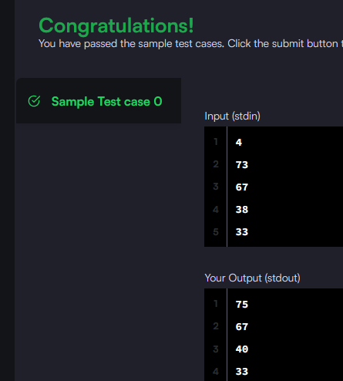
TASK 7:
class Animal {
void walk() {
System.out.println("I am walking");
}
}

class Bird extends Animal {
void fly() {
System.out.println("I am flying");
}

void sing() {
System.out.println("I am singing");
}
}

public class Solution {
public static void main(String[] args) {

Bird bird = new Bird();
bird.walk();
bird.fly();
bird.sing(); // added this line
}
}
OUTPUT :
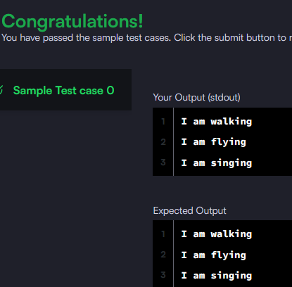
TASK 8:
class Arithmetic {
int add(int a, int b) {
return a + b;
}
}

class Adder extends Arithmetic {
}

public class Solution {
public static void main(String[] args) {
Adder a = new Adder();

System.out.println("My superclass is: " + a.getClass().getSuperclass().getName());
System.out.print(a.add(10, 32) + " " + a.add(10, 3) + " " + a.add(10, 10));
}
}
OUTPUT :
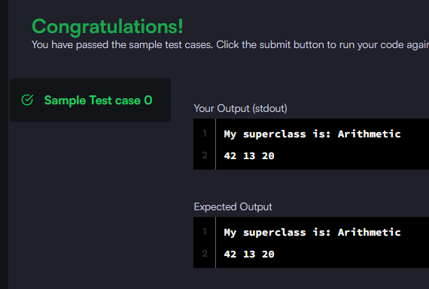
TASK 9:
import java.util.*;

class Printer {

// Generic method
public <T> void printArray(T[] array) {
for (T element : array) {
System.out.println(element);
}
}
}

public class Solution {

public static void main(String[] args) {
Printer printer = new Printer();

Integer[] intArray = {1, 2, 3};
String[] stringArray = {"Hello", "World"};

printer.printArray(intArray);
printer.printArray(stringArray);
}
}
OUTPUT :
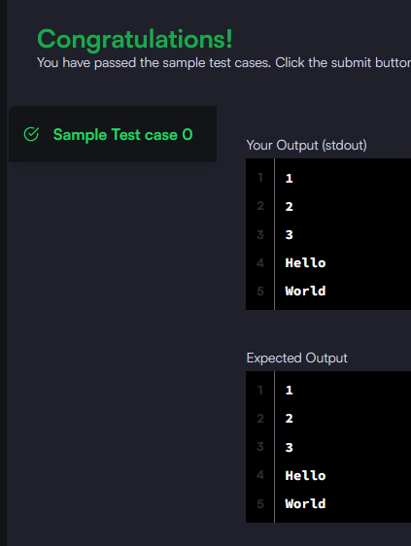

TASK 10 :
import java.util.*;

class ThroneInheritance {
String king;
Map<String, List<String>> children;
Set<String> dead;

public ThroneInheritance(String kingName) {
king = kingName;
children = new HashMap<>();
dead = new HashSet<>();
}

public void birth(String parentName, String childName) {
children.putIfAbsent(parentName, new ArrayList<>());
children.get(parentName).add(childName);
}

public void death(String name) {
dead.add(name);
}

public List<String> getInheritanceOrder() {
List<String> result = new ArrayList<>();
dfs(king, result);
return result;
}

private void dfs(String person, List<String> result) {
if (!dead.contains(person)) {
result.add(person);
}
if (children.containsKey(person)) {
for (String child : children.get(person)) {
dfs(child, result);
}
}
}
}
OUTPUT :
